Date: 21/1/2019
DAILY REPORT ON WIT & WIL
Name of the faculty : V.BABY Name of the subject : Programming through C
Class/ Section : I B.Tech II sem CSE – D
1 | Grid Reference No : | 1.1
2 | Scenario Reference: |   Pin validation, Amount updation, Balance verification etc. -All operations are performed by different set of operators
3 | Topic Covered: | Operators- Bitwise, Conditional, Short Hand Assignment Operators, Expression Evaluation
4 | Brief Write – up (500 words):  An expression is a sequence of operands and operators that reduces to a single value. For example, the expression, 10+5 reduces to the value of 15.  Based on the operators and operators used in the expression, they are divided into several types. Some of them are:  - Integer expressions – expressions which contains integers and operators  - Real expressions – expressions which contains floating point values and operators  - Arithmetic expressions – expressions which contain operands and arithmetic operators  - Mixed mode arithmetic expressions – expressions which contain both integer and real operands  - Relational expressions – expressions which contain relational operators and operands  - Logical expressions – expressions which contain logical operators and operands  - Assignment expressions and so on… – expressions which contain assignment operators and operands  Expression Evaluation  Expressions are evaluated using an assignment statement of the form:    In the above syntax, variable is any valid C variable name. When the statement like the above form is encountered, the expression is evaluated first and then the value is assigned to the variable on the left hand side.  All variables used in the expression must be declared and assigned values before evaluation is attempted. Examples of expressions are:  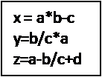  Expressions are evaluated based on operator precedence and associativity rules when an expression contains more than one operator.  Operator Precedence and Associativity  Every C operator has a precedence (priority) associated with it. This precedence is used to determine how an expression involving more than one operator is evaluated.  There are different levels of operator precedence and an operator may belong to one of these levels. The operators at the higher level of precedence are evaluated first. The operators in the same level of precedence are evaluated from left to right or from right to left, based on the associativity property of an operator.  In the below table we can look at the precedence levels of operators and also the associativity of the operators within the same level. Rank 0 indicates the lowest precedence and Rank 14 indicates highest precedence.  The precedence and associativity of various operators in C are as given below:  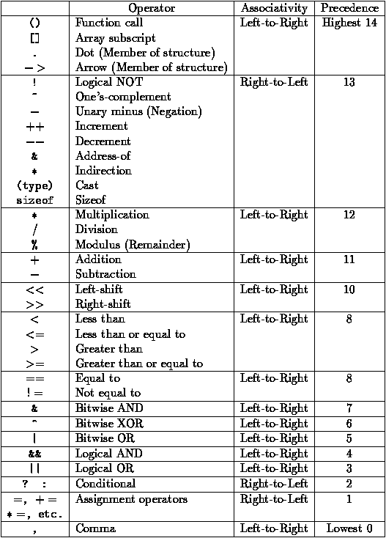
5 | Relevant additional illustration if any : sequence of steps for Money withdraw in ATM
6 | Video links / web links if any: | https://www.startertutorials.com/blog/expression.html
7 | Signature of Repository Administrator:

